Kennedy Uzoho
SNHU-CS-255 Client’s Project Presentation
2/25/2022



Slide 2
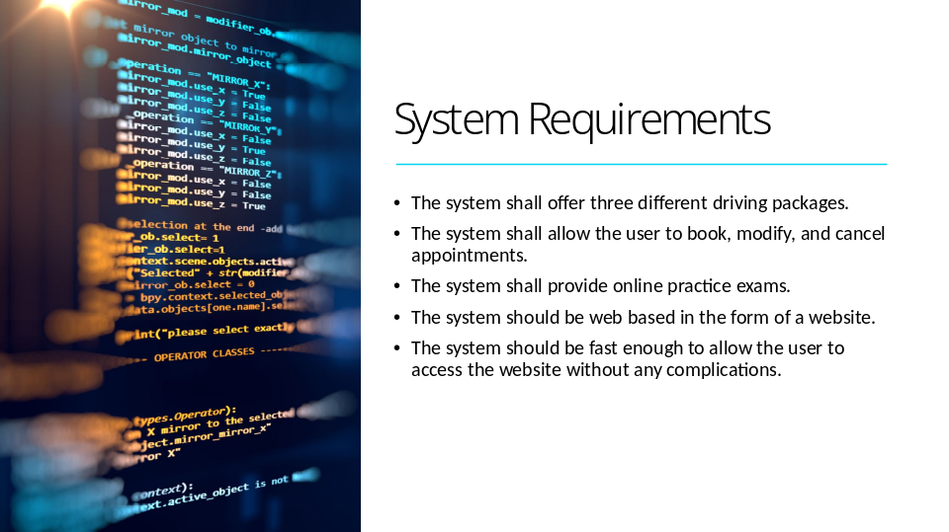
The system shall validate user credentials when logging in.
The system shall update all data and information between platforms.
The system shall allow a user to reset their password.
The system shall allow data to be modified on any platform.
The system shall tell the progress of scheduled training and hours taken.
The system shall be updated with any DMV regulations or laws.
The system shall show online test progress.
The system shall display user information.
The system shall be flexible and able to modify to add new features.

The system needs to run fast enough to quickly update its web browser and its corresponding applications.
The system should be updated after each modification and on a scheduled basis.
Modification:
- New Security Update
- Reports of Crash/Buggs
- General Updates/Scheduled Updates
- New DMV test regulations, new laws, and legal/illegal driving information

Slide 3
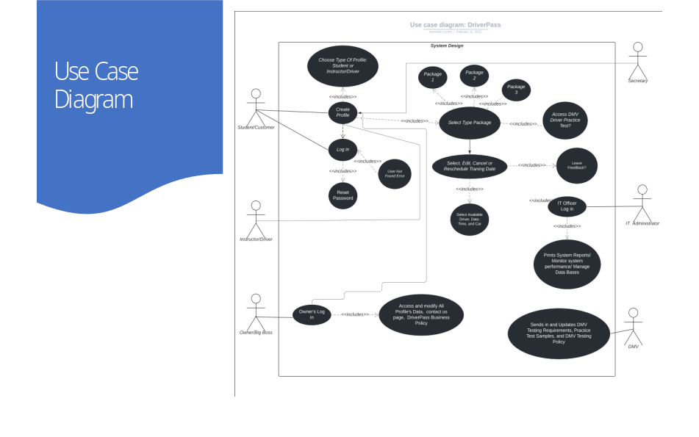
In this use case diagram, the different actors include customer/student, Instructor/driver, Owner/BigBoss, IT admin, and Secretory. The DMV could be a type of add-on that automates and update DriverPass database with the most updated DMV rules and regulations.

Slide 4
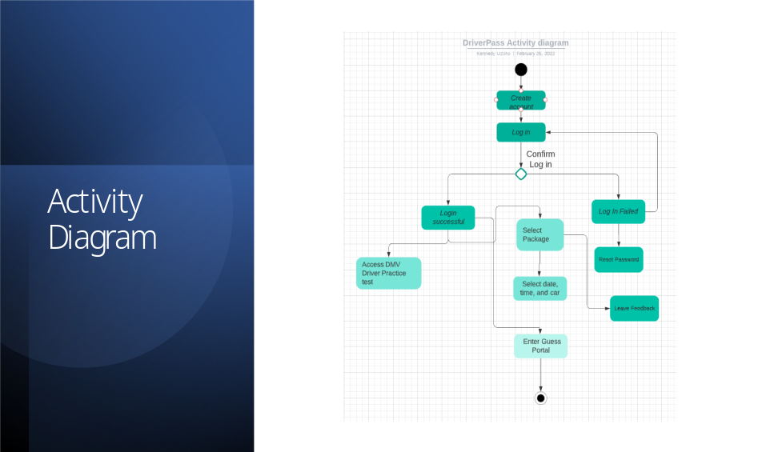

In this activity diagram, the different actors include customer/student, Instructor/driver, Owner/BigBoss, IT admin, and Secretory. The DMV could be a type add on that automate and update DriverPass database with the most updated DMV rules and regulations.

The Use Case for this activity diagram is mainly designed for the guest/customer and any available secretary that will register and schedule customer.

Slide 5
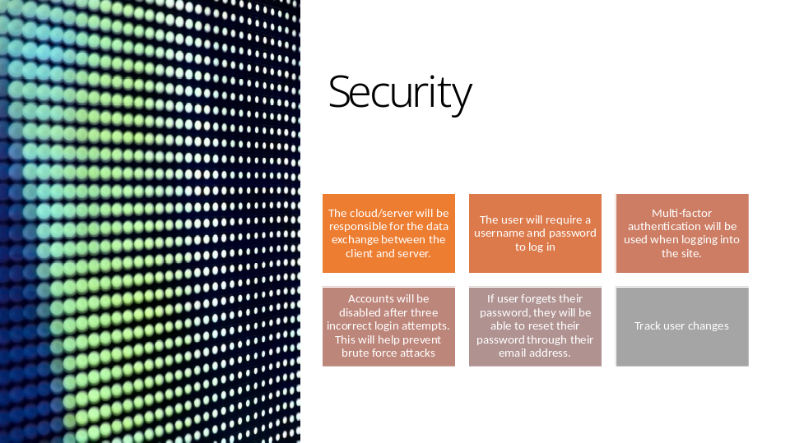

The user will require a username and password to log in
Multi-factor authentication will be used when logging into the site.
Accounts will be disabled after three incorrect login attempts. This will help prevent brute force attacks
If user forgets their password, they will be able to reset their password through their email address.
Track user’s changes

Slide 6
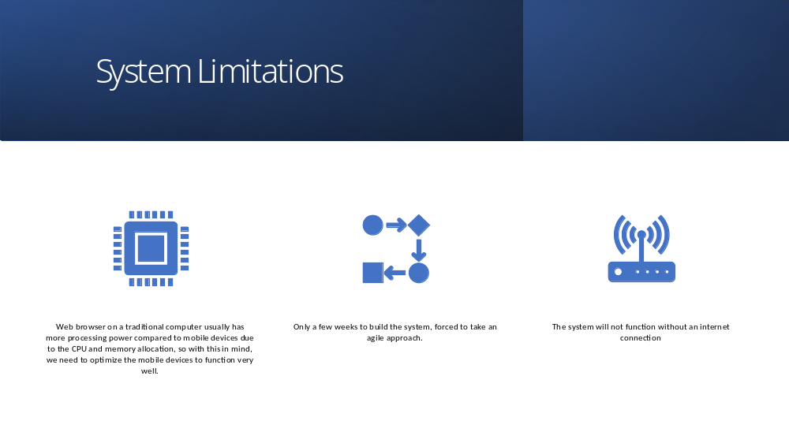
- May not be able to operate offline to avoid duplication of data
- We should be good on the budget unless a serious issue, flaw, disturbs the project.
- Not so many technical limitations, however a web browser on a traditional computer usually has more processing power compared to mobile devices due to the CPU and memory allocation, so with this in mind, we need to optimize the mobile devices to function very well.

